CHAT Youth Counselling OVERVIEW

Our centre of operation is Oundle. However, we extend to Thrapston, Brigstock, and the borders of Lincolnshire and Peterborough. We provide this professional counselling service in our offices in Oundle, at Prince William School and the Souster Youth Offices in Thrapston and the primary schools in this area. 1743 sessions were delivered in 2022-23. During the COVID pandemic telephone and online approaches were introduced and continue to be offered to clients.

This work with 11-18 year olds and those up to 25 years with Special Educational Needs is funded primarily by the Integrated Care Board and Public Health. Agreed Core funding for 2023-24 is £87k. Our work with 9- and 10-year-olds and those aged 18 to 25 (without Special Educational Needs) is dependent on seeking other funding.

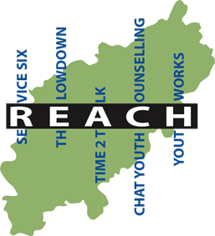
We run a Wellbeing Café in Thrapston at Souster Youth every week from 4pm to 8pm for 10 -18 years olds and their parents/ guardians. Here we offer advice for young people in a crisis or with difficulties, in a confidential environment, as well as support for the parents. If we cannot assist, we refer those that attend to the agencies that can.

We provide our service as part of the REACH Collaborative, a cooperation between five youth counselling organisations, who together cover the whole of Northamptonshire. Over the past few years, the collabotation has enabled us to deliver at least one project a year with our Reach partners, based on analysis of client need.

Staffing

CHAT Youth Counselling employs 3 staff members, working flexibly between the various service venues, CHAT Office and from home. Currently 2 sessional counsellors are also used. CHAT has, on occasion, benefited from trainee counsellors.

Referrals are taken through the CAMHS Referral Management Centre, directly from GPs and other medical professionals, schools, parents and the young people themselves. Following an initial assessment, professionals provide a six-session course of either counselling or therapeutic
mentoring, as appropriate. At this point, there is a review resulting in one of the following outcomes:- case closure, a referral onto other support agency, or an extended counselling agreement, as required.

